Practical 1
#include <iostream> using namespace std;
// Global variable to count recursive calls int callCount = 0;
// Recursive Fibonacci function int fibonacci(int n) {
callCount++; // Increment count for each call if (n == 0)
return 0; if (n == 1) return 1;
return fibonacci(n - 1) + fibonacci(n - 2);
}
int main() { int limit;
cout << "Enter the number of terms: "; cin >> limit;
cout << "Fibonacci Series: "; for (int i = 0; i < limit; i++) { cout << fibonacci(i) << " ";
}
cout << endl;
cout << "Total Recursive Calls: " << callCount << endl; return 0;
}
Output :-
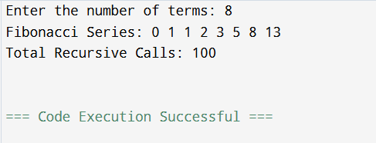

Practical 1
#include <stdio.h> #include <time.h>
// Iterative function for factorial long long factorial_iterative(int n) { long long result = 1;
int i;
for (i = 1; i <= n; i++) \ result *= i;
return result;
}
// Recursive function for factorial long long factorial_recursive(int n) { if (n == 0 || n == 1)
return 1; else
return n * factorial_recursive(n - 1);
}
int main() { int n;
clock_t start, end; double cpu_time_used; long long result;
printf("Harshwardhan D:\n"); printf("PRN 32558013205:\n");
printf("Enter a number to find factorial: "); scanf("%d", &n);
// Iterative function timing start = clock();
result = factorial_iterative(n); end = clock();
cpu_time_used = ((double)(end - start)) / CLOCKS_PER_SEC;

printf("\n[Iterative] Factorial of %d = %lld", n, result); printf("\n[Iterative] Time taken: %f seconds", cpu_time_used); printf("\n[Iterative] Space Complexity ̃ ˜ O(1)\n");
// Recursive function timing start = clock();
result = factorial_recursive(n); end = clock();
cpu_time_used = ((double)(end - start)) / CLOCKS_PER_SEC; printf("\n[Recursive] Factorial of %d = %lld", n, result); printf("\n[Recursive] Time taken: %f seconds", cpu_time_used); printf("\n[Recursive] Space Complexity ̃ ˜ O(n) (due to recursion stack)\n"); return 0;
}

Output:-
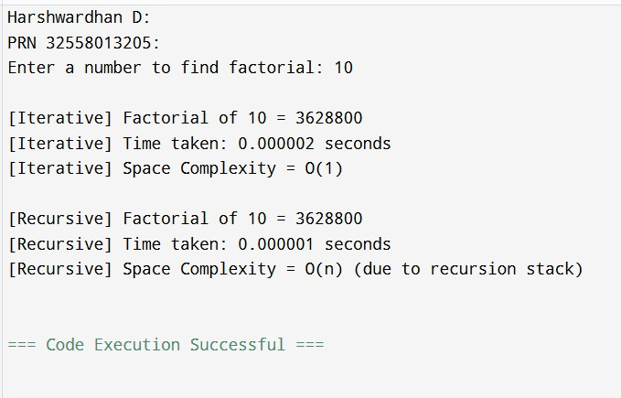

Practical 2

#include <stdio.h> #include <time.h>
// Recursive Binary Search Function
int binarySearch(int arr[], int low, int high, int key) { if (low <= high) {
int mid = low + (high - low) / 2; if (arr[mid] == key)
return mid; if (arr[mid] > key)
return binarySearch(arr, low, mid - 1, key return binarySearch(arr, mid + 1, high, key);
}
return -1;
}
int main() {
int arr[100000], n, key, result; clock_t start, end;
double cpu_time_used; int i;
printf("Recursive Binary Search\n"); printf(" \n");
// Your details
printf("\nName : Harshwardhan D \n"); printf("PRN : 32558013205\n\n"); printf("Enter number of elements: "); scanf("%d", &n);
printf("Enter %d elements in sorted order:\n", n); for (i = 0; i < n; i++) {
scanf("%d", &arr[i]);
}
printf("Enter the element to search: "); scanf("%d", &key);

start = clock();
result = binarySearch(arr, 0, n - 1, key); end = clock();
cpu_time_used = ((double)(end - start)) / CLOCKS_PER_SEC; if (result != -1)
printf("\nElement %d found at position %d.\n", key, result + 1); else
printf("\nElement %d not found in the array.\n", key);
printf("\nTime taken by recursive binary search: %.10f seconds", cpu_time_used);

printf("\nTheoretical Time Complexity: O(log n)"); printf("\nSpace Complexity (due to recursion stack): O(log n)\n");
return 0;
}

Output:-

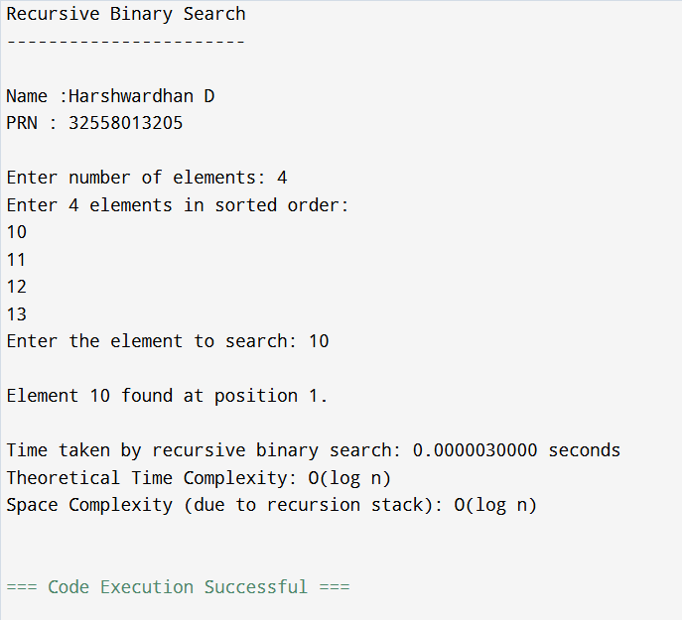

Practical 3

#include <stdio.h> #include <time.h>
#define MAX 100 // maximum size void bubbleSort(int a[], int n) {
int i, j, temp;
for (i = 0; i < n - 1; i++) {
for (j = 0; j < n - i - 1; j++) {
if (a[j] > a[j + 1]) { temp = a[j];
a[j] = a[j + 1]; a[j + 1] = temp;
}
}
}
}
void insertionSort(int a[], int n) { int i, key, j;
for (i = 1; i < n; i++) { key = a[i];
j = i - 1;
while (j >= 0 && a[j] > key) { a[j + 1] = a[j];
j--;
}
a[j + 1] = key;
}}
// Function to display array
void displayArray(int a[],int n) { int i;
for (i = 0; i < n; i++)

printf("%d ", a[i]);
}
printf("\n");
}
int main(){ int n,i;
int a[MAX],b[MAX];
clock_t start, end;
double bubbleTime,insertionTime; printf("SortingAlgorithm Comparison\n"); printf(" \n");
//??Yourdetailsadded here printf("\nName: Harshwardhan D\n\n"); printf("PRN: 32558013205\n\n"); printf("Enter numberof elements: "); scanf("%d", &n);
if(n >MAX){
printf("Too many elements! Max = %d\n", MAX); return 0;
}
printf("Enterelements:\n"); for (i = 0; i < n; i++) {
scanf("%d", &a[i]); b[i] = a[i];
}
//Bubble Sort Time start = clock(); bubbleSort(a, n); end = clock();
bubbleTime = (double)(end - start) / CLOCKS_PER_SEC; printf("\nSorted Array using Bubble Sort:\n");
displayArray(a, n);
//Insertion Sort Time start =

clock(); insertionSort(b, n);

= clock();
insertionTime = (double)(end - start) / CLOCKS_PER_SEC; printf("\nSorted Array using Insertion Sort:\n"); displayArray(b, n);
//Display time taken
printf("\nBubble Sort Time: %f seconds", bubbleTime); printf("\nInsertion Sort Time: %f seconds\n", insertionTime); return 0;
}

Output:-
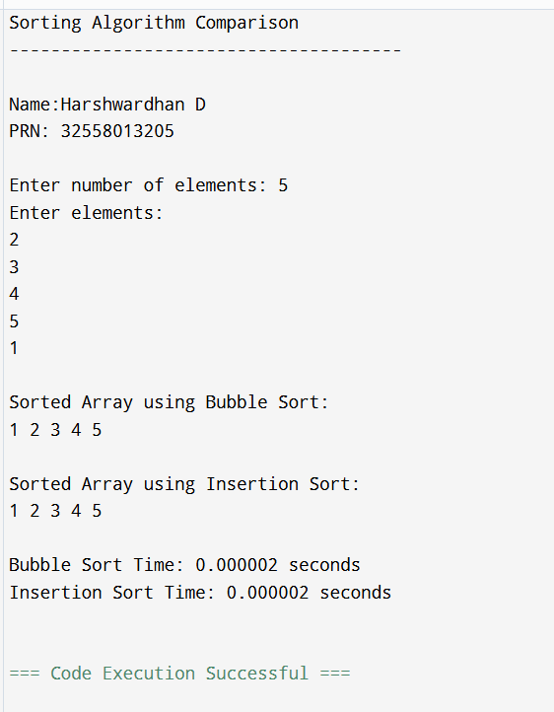

Practical 4

#include <stdio.h> #include <stdlib.h> struct MinHeapNode {
char data; unsigned freq;
struct MinHeapNode *left, *right;
};
struct MinHeap { unsigned size; unsigned capacity;
struct MinHeapNode** array;
};
struct MinHeapNode* newNode(char data, unsigned freq) {
struct MinHeapNode* temp = (struct MinHeapNode*)malloc(sizeof(struct MinHeapNode)); temp->left = temp->right = NULL;
temp->data = data; temp->freq = freq; return temp;
}
struct MinHeap* createMinHeap(unsigned capacity) {
struct MinHeap* minHeap = (struct MinHeap*)malloc(sizeof(struct MinHeap)); minHeap->size = 0;
minHeap->capacity = capacity;
minHeap->array = (struct MinHeapNode**)malloc(minHeap->capacity * sizeof(struct MinHeapNode*)); return minHeap;
}
void swapMinHeapNode(struct MinHeapNode** a, struct MinHeapNode** b) { struct MinHeapNode* t = *a;
*a = *b;
*b = t;
}
void minHeapify(struct MinHeap* minHeap, int idx) { int smallest = idx;
int left = 2 * idx + 1; int right = 2 * idx + 2;
if (left < minHeap->size && minHeap->array[left]->freq < minHeap->array[smallest]->freq) smallest = left;
if (right < minHeap->size && minHeap->array[right]->freq < minHeap->array[smallest]->freq) smallest = right;
if (smallest != idx) {
swapMinHeapNode(&minHeap->array[smallest], &minHeap->array[idx]); minHeapify(minHeap, smallest);
}
}

struct MinHeapNode* extractMin(struct MinHeap* minHeap) { struct MinHeapNode* temp = minHeap->array[0];
minHeap->array[0] = minHeap->array[minHeap->size - 1];
--minHeap->size; minHeapify(minHeap, 0); return temp;
}
void insertMinHeap(struct MinHeap* minHeap, struct MinHeapNode* minHeapNode) {
++minHeap->size;
int i = minHeap->size - 1;
while (i && minHeapNode->freq < minHeap->array[(i - 1) / 2]->freq) { minHeap->array[i] = minHeap->array[(i - 1) / 2];
i = (i - 1) / 2;
}
minHeap->array[i] = minHeapNode;
}
struct MinHeapNode* buildHuffmanTree(char data[], int freq[], int size) { struct MinHeapNode *left, *right, *top;
struct MinHeap* minHeap = createMinHeap(size); for (int i = 0; i < size; ++i)
minHeap->array[i] = newNode(data[i], freq[i]); minHeap->size = size;
while (minHeap->size != 1) { left = extractMin(minHeap); right = extractMin(minHeap);
top = newNode('$', left->freq + right->freq); top->left = left;
top->right = right; insertMinHeap(minHeap, top);
}
return extractMin(minHeap);
}
void printCodes(struct MinHeapNode* root, int arr[], int top) { if (root->left) {
arr[top] = 0;
printCodes(root->left, arr, top + 1);
}
if (root->right) { arr[top] = 1;
printCodes(root->right, arr, top + 1);
}

if (!(root->left) && !(root->right)) {
printf("%c: ", root->data); for (int i = 0; i < top; ++i)
printf("%d", arr[i]); printf("\n");

}
}

int main() {
char arr[] = {'A', 'B', 'C', 'D', 'E', 'F'}; int freq[] = {5, 9, 12, 13, 16, 45};
int size = sizeof(arr) / sizeof(arr[0]);
struct MinHeapNode* root = buildHuffmanTree(arr, freq, size); int code[100], top = 0;
printf("Huffman Codes are:\n"); printCodes(root, code, top);

return 0;
}

Output:-

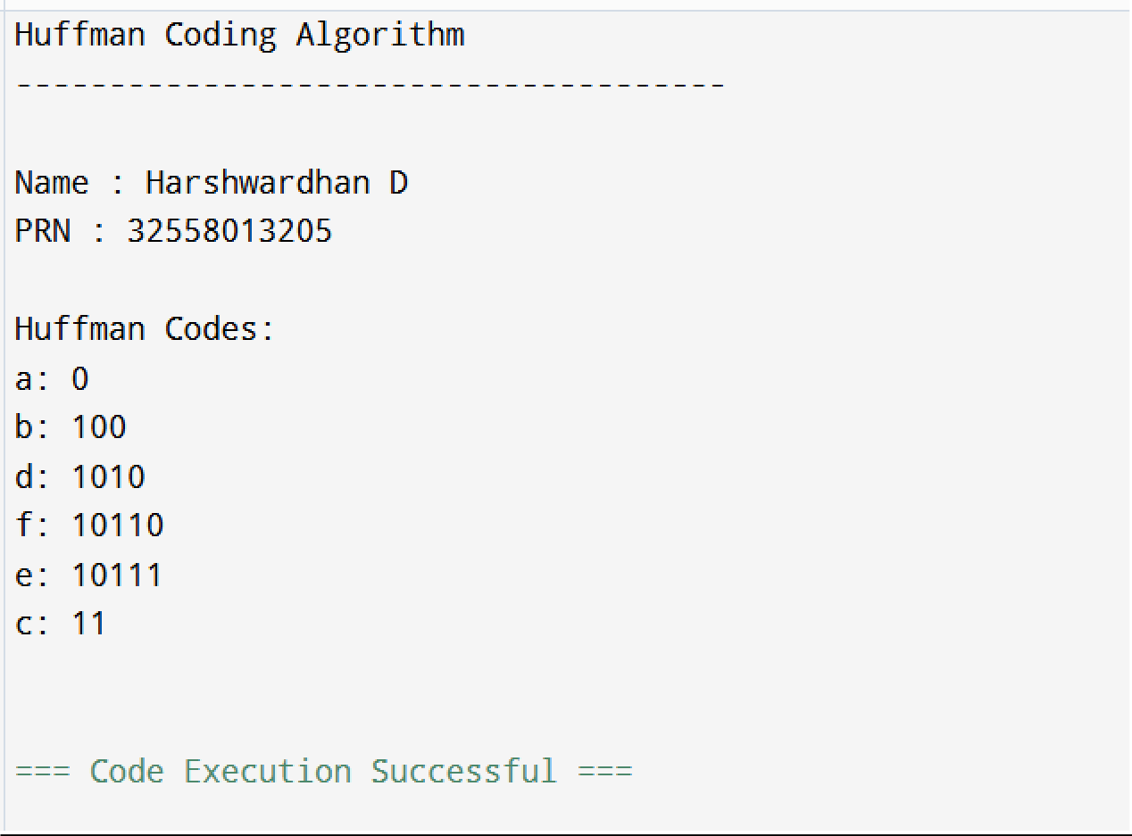

Practical 5

#include <stdio.h> #include <stdlib.h> #include <time.h> #define INF 9999
#define MAX 100
// ---------- STRUCTURE FOR EDGE (Used in Kruskal) ----------
typedef struct { int u, v, w;
} Edge;
// ---------- UNION-FIND FUNCTIONS (for Kruskal) ----------
int find(int parent[], int i) { while (parent[i] != i)
i = parent[i]; return i;
}
void unionSets(int parent[], int u, int v) { int uRoot = find(parent, u);
int vRoot = find(parent, v); parent[uRoot] = vRoot;
}
// ---------- PRIM'S ALGORITHM ----------
void primMST(int cost[MAX][MAX], int n) { int selected[MAX] = {0};
int no_edge = 0, x, y; int totalCost = 0;
selected[0] = 1; // Start from vertex 0 printf("\nPrim’s Algorithm Edges:\n"); while (no_edge < n - 1) {
int min = INF; x = 0;
y = 0;
for (int i = 0; i < n; i++) { if (selected[i]) {
for (int j = 0; j < n; j++) {
if (!selected[j] && cost[i][j]) { if (min > cost[i][j]) {

min = cost[i][j]; x = i;
y = j;
}
}
}
printf("Edge %d: (%d - %d) cost: %d\n", no_edge + 1, x, y, cost[x][y]); totalCost += cost[x][y];
selected[y] = 1; no_edge++;
}
printf("Total cost using Prim’s Algorithm = %d\n", totalCost);
}
// ---------- KRUSKAL'S ALGORITHM ----------
void kruskalMST(int cost[MAX][MAX], int n) { Edge edges[MAX * MAX];
int edgeCount = 0;
// Convert adjacency matrix to edge list for (int i = 0; i < n; i++) {
for (int j = i + 1; j < n; j++) {
if (cost[i][j] != 0 && cost[i][j] != INF) { edges[edgeCount].u = i; edges[edgeCount].v = j; edges[edgeCount].w = cost[i][j]; edgeCount++;
}
}
// Sort edges by weight (simple bubble sort) for (int i = 0; i < edgeCount - 1; i++) {
for (int j = 0; j < edgeCount - i - 1; j++) { if (edges[j].w > edges[j + 1].w) {
Edge temp = edges[j]; edges[j] = edges[j + 1]; edges[j + 1] = temp;
}
}
int parent[MAX];
for (int i = 0; i < n; i++)

parent[i] = i;
int totalCost = 0, edgeAdded = 0; printf("\nKruskal’s Algorithm Edges:\n");
for (int i = 0; i < edgeCount && edgeAdded < n - 1; i++) { int uRoot = find(parent, edges[i].u);
int vRoot = find(parent, edges[i].v); if (uRoot != vRoot) {
printf("Edge %d: (%d - %d) cost: %d\n", edgeAdded + 1, edges[i].u, edges[i].v, edges[i].w); totalCost += edges[i].w;
unionSets(parent, uRoot, vRoot); edgeAdded++;
}
printf("Total cost using Kruskal’s Algorithm = %d\n", totalCost);
}
// ---------- MAIN FUNCTION ----------
int main() {
int n, cost[MAX][MAX];

printf("Enter number of vertices: "); scanf("%d", &n);
printf("Enter the cost adjacency matrix (use 0 for no edge):\n"); for (int i = 0; i < n; i++) {
for (int j = 0; j < n; j++) { scanf("%d", &cost[i][j]);
if (cost[i][j] == 0 && i != j)
cost[i][j] = INF;
}
// Measure execution time for Prim’s clock_t start, end;
double primTime, kruskalTime; start = clock();
primMST(cost, n); end = clock();
primTime = ((double)(end - start)) / CLOCKS_PER_SEC;
// Measure execution time for Kruskal’s start = clock();
kruskalMST(cost, n); end = clock();

kruskalTime = ((double)(end - start)) / CLOCKS_PER_SEC; printf("\n⏱️ Execution Time Comparison:");
printf("\nPrim’s Algorithm Time: %.10f seconds", primTime);
printf("\nKruskal’s Algorithm Time: %.10f seconds\n", kruskalTime); return 0;
}

Output:-
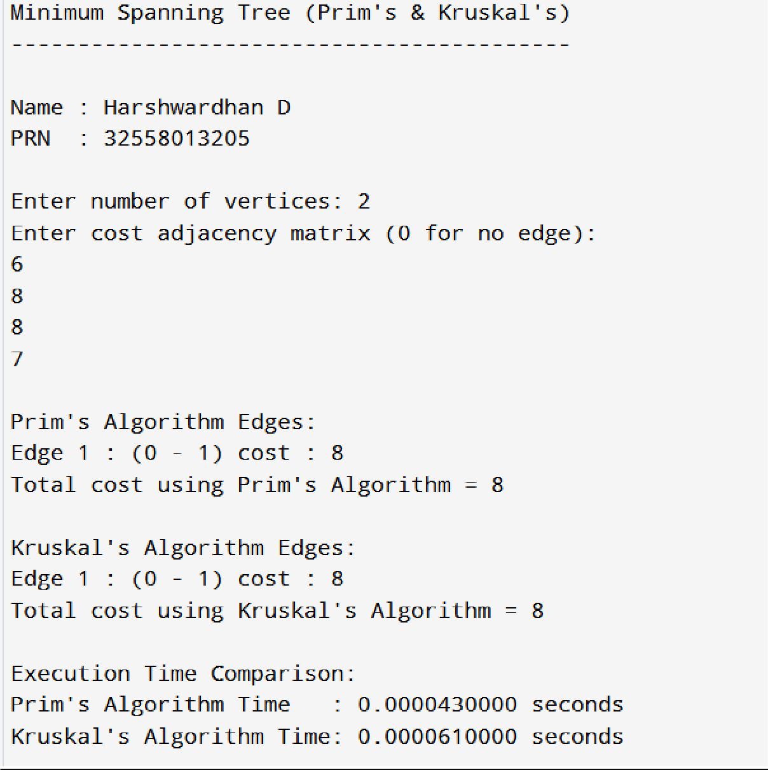

Practical 6

#include <stdio.h>
// Function to return maximum of two numbers int max(int a, int b) {
return (a > b) ? a : b;
}
// Function to solve 0/1 Knapsack using Dynamic Programming int knapSack(int W, int wt[], int val[], int n) {
int i, w;
int K[n + 1][W + 1];
// Build table K[][] in bottom-up manner for (i = 0; i <= n; i++) {
for (w = 0; w <= W; w++) { if (i == 0 || w == 0)
K[i][w] = 0;
else if (wt[i - 1] <= w)
K[i][w] = max(val[i - 1] + K[i - 1][w - wt[i - 1]], K[i - 1][w]); else
K[i][w] = K[i - 1][w];
}
}
// Display DP Table
printf("\nDynamic Programming Table:\n"); for (i = 0; i <= n; i++) {
for (w = 0; w <= W; w++) { printf("%3d ", K[i][w]);
}
printf("\n");
}
return K[n][W]; // Final maximum value
}
int main() {
int val[20], wt[20], W, n, i; printf("Enter number of items: "); scanf("%d", &n);
printf("Enter values (profits) of %d items:\n", n); for (i = 0; i < n; i++) {

scanf("%d", &val[i]);
}
printf("Enter weights of %d items:\n", n); for (i = 0; i < n; i++) {
scanf("%d", &wt[i]);
}
printf("Enter capacity of Knapsack: "); scanf("%d", &W);
int maxValue = knapSack(W, wt, val, n);
printf("\nMaximum value that can be put in the knapsack = %d\n", maxValue); return 0;
}

Output:-
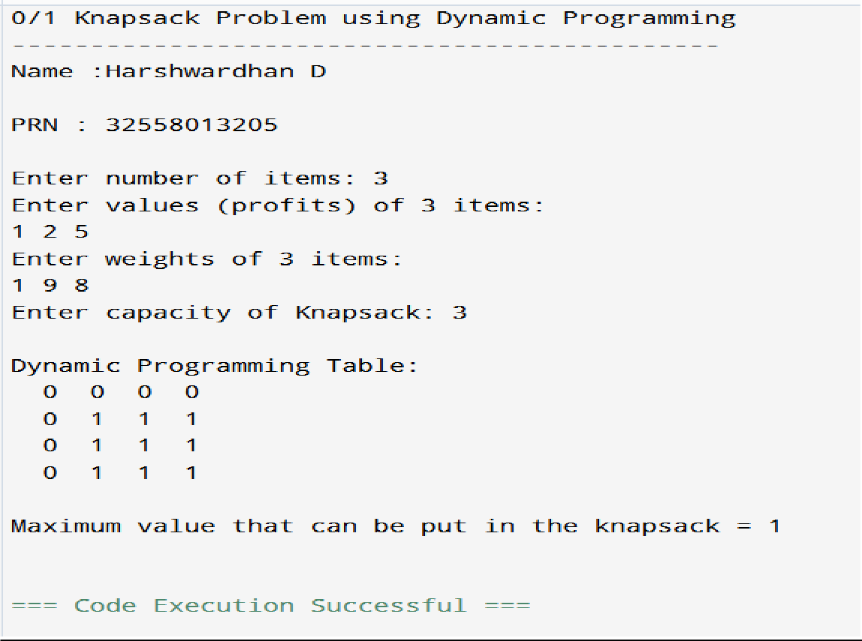

Practical 7

#include <stdio.h> #include <string.h>
int max(int a, int b) { return (a > b)? a : b; } void LCS(char X[], char Y[], int m, int n) {
int dp[m+1][n+1];
for (int i = 0; i <= m; i++) { for (int j = 0; j <= n; j++) {
if (i == 0 || j == 0) dp[i][j] = 0;
else if (X[i-1] == Y[j-1])
dp[i][j] = dp[i-1][j-1] + 1; else
dp[i][j] = max(dp[i-1][j], dp[i][j-1]);
}
}
printf("Length of LCS is %d\n", dp[m][n]);
}
int main() {
char X[] = "AGGTAB"; char Y[] = "GXTXAYB";
int m = strlen(X); int n = strlen(Y); LCS(X, Y, m, n);
return 0;
}

Output:-
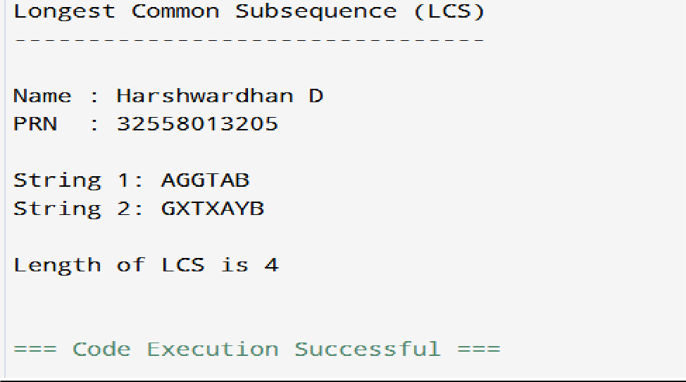

Practical 8

#include <stdio.h> #define MAX 10

int adj[MAX][MAX], visited[MAX], n;

// BFS Function void bfs(int start) {
int queue[MAX], front = 0, rear = 0; visited[start] = 1;
queue[rear++] = start; printf("BFS Traversal: ");
while (front < rear) {
int node = queue[front++]; printf("%d ", node);
for (int i = 0; i < n; i++) {
if (adj[node][i] && !visited[i]) { queue[rear++] = i;
visited[i] = 1;
}
}
}
printf("\n");
}

// DFS Function void dfs(int start) {
printf("%d ", start); visited[start] = 1;
for (int i = 0; i < n; i++) {
if (adj[start][i] && !visited[i]) { dfs(i);
}
}
}

int main() { int i, j, start;
printf("Enter number of vertices: "); scanf("%d", &n);

printf("Enter adjacency matrix:\n"); for (i = 0; i < n; i++) {
for (j = 0; j < n; j++) { scanf("%d", &adj[i][j]);
}
}

printf("Enter starting vertex: "); scanf("%d", &start);

for (i = 0; i < n; i++) visited[i] = 0; bfs(start);
for (i = 0; i < n; i++) visited[i] = 0; printf("DFS Traversal: "); dfs(start);
printf("\n");

return 0;
}

Output:-

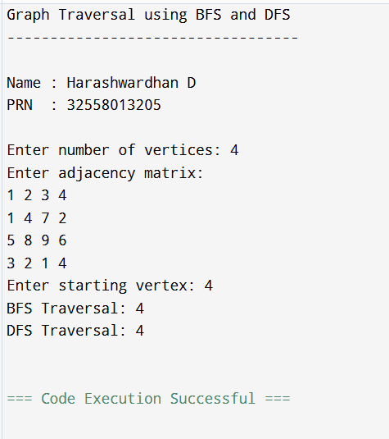

Practical 9

#include <stdio.h>

#define V 4 // Number of vertices #define INF 99999 // Infinity (large value)

// Function to print the distance matrix void printSolution(int dist[V][V]) {
printf("\nShortest distances between every pair of vertices:\n"); for (int i = 0; i < V; i++) {
for (int j = 0; j < V; j++) { if (dist[i][j] == INF)
printf("%7s", "INF"); else
printf("%7d", dist[i][j]);
}
printf("\n");
}
}
// Function to implement Floyd–Warshall Algorithm void floydWarshall(int graph[V][V]) {
int dist[V][V]; // Matrix to store shortest path distances
// Step 1: Initialize distance matrix same as input graph for (int i = 0; i < V; i++)
for (int j = 0; j < V; j++) dist[i][j] = graph[i][j];
// Step 2: Update distance matrix using dynamic programming for (int k = 0; k < V; k++) { // Pick all vertices as intermediate
for (int i = 0; i < V; i++) { // Pick all vertices as source
for (int j = 0; j < V; j++) { // Pick all vertices as destination if (dist[i][k] + dist[k][j] < dist[i][j])
dist[i][j] = dist[i][k] + dist[k][j];
}
}
}
// Step 3: Print the final shortest distance matrix

printSolution(dist);
}
int main() {
/* Input weighted graph as adjacency matrix 0 indicates self-loop
INF means no direct edge between the vertices */ int graph[V][V] = {
{0, 5, INF, 10},
{INF, 0, 3, INF},
{INF, INF, 0, 1},
{INF, INF, INF, 0}
};
printf("Floyd–Warshall Algorithm Implementation\n"); printf(" \n");
floydWarshall(graph);

return 0;
}

Output:-

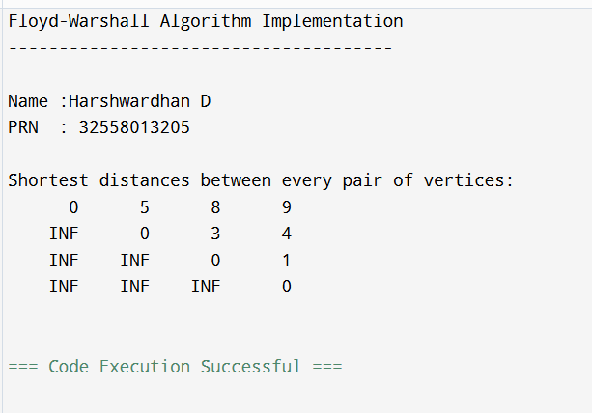

Practical 10

#include <stdio.h> #include <stdbool.h> #include <limits.h> #include <math.h>
#define N 4 // Number of cities #define INF 9999
int costMatrix[N][N] = {
{0, 10, 15, 20},
{10, 0, 35, 25},
{15, 35, 0, 30},
{20, 25, 30, 0}
};
// ---------- FUNCTION: Find Minimum Cost Using Brute Force (Exact TSP) ---------- int minCost = INF;
int visitedAll = (1 << N) - 1;
int dp[1 << N][N]; // DP for memoization int tspExact(int mask, int pos) {
if (mask == visitedAll)
return costMatrix[pos][0]; // return to starting point if (dp[mask][pos] != -1)
return dp[mask][pos]; int ans = INF;
for (int city = 0; city < N; city++) {
if ((mask & (1 << city)) == 0) { // if not visited
int newAns = costMatrix[pos][city] + tspExact(mask | (1 << city), city); if (newAns < ans)
ans = newAns;
}
dp[mask][pos] = ans; return ans;
}
// ---------- FUNCTION: Find Approximate Solution using Nearest Neighbor ---------- int tspApprox() {
bool visited[N] = {false}; int totalCost = 0;
int current = 0; // Start from city 0

visited[0] = true;
printf("\nNearest Neighbor Path: 0"); for (int count = 1; count < N; count++) {
int nearest = -1; int minDist = INF;
for (int j = 0; j < N; j++) {
if (!visited[j] && costMatrix[current][j] < minDist && costMatrix[current][j] != 0) { minDist = costMatrix[current][j];
nearest = j;
}
visited[nearest] = true; totalCost += minDist; current = nearest; printf(" -> %d", current);
}
totalCost += costMatrix[current][0]; // return to start printf(" -> 0\n");
return totalCost;
}
// ---------- MAIN FUNCTION ----------
int main() { int i, j;
for (i = 0; i < (1 << N); i++)
for (j = 0; j < N; j++) dp[i][j] = -1;
printf("Traveling Salesperson Problem (TSP) Comparison\n"); printf(" \n");
// Exact solution using Dynamic Programming (Bitmask) int exactCost = tspExact(1, 0);
// Approximation using Nearest Neighbor int approxCost = tspApprox();
// Compute approximation error
double errorPercent = ((double)(approxCost - exactCost) / exactCost) * 100.0; printf("\nOptimal (Exact) TSP Cost = %d", exactCost); printf("\nApproximate (Nearest Neighbor) TSP Cost = %d", approxCost); printf("\nApproximation Error = %.2f%%\n", errorPercent);

return 0;

}
Output:-
